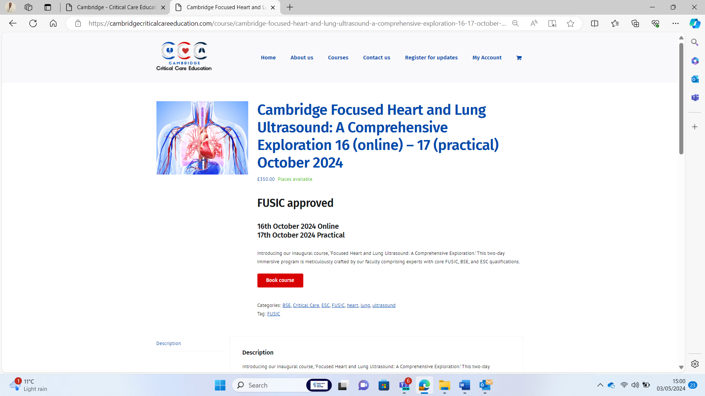

[Cambridge Focused Heart and Lung Ultrasound: A Comprehensive Exploration 16 (online) - 17 (practical) October 2024 - Cambridge Critical Care Education](https://cambridgecriticalcareeducation.com/course/cambridge-focused-heart-and-lung-ultrasound-a-comprehensive-exploration-16-17-october-2024/)

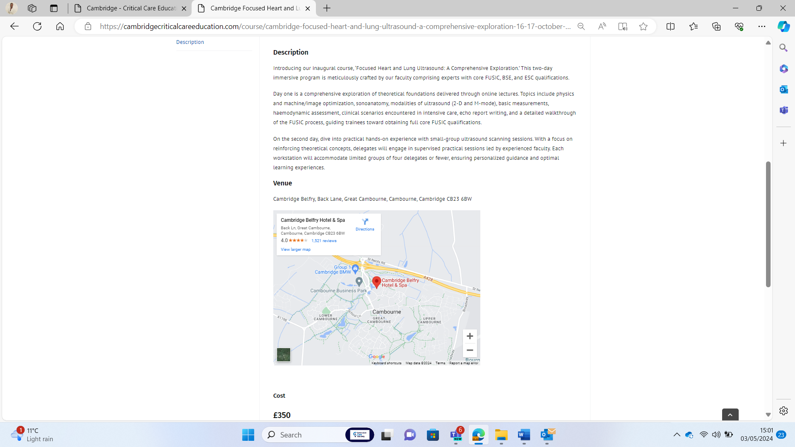

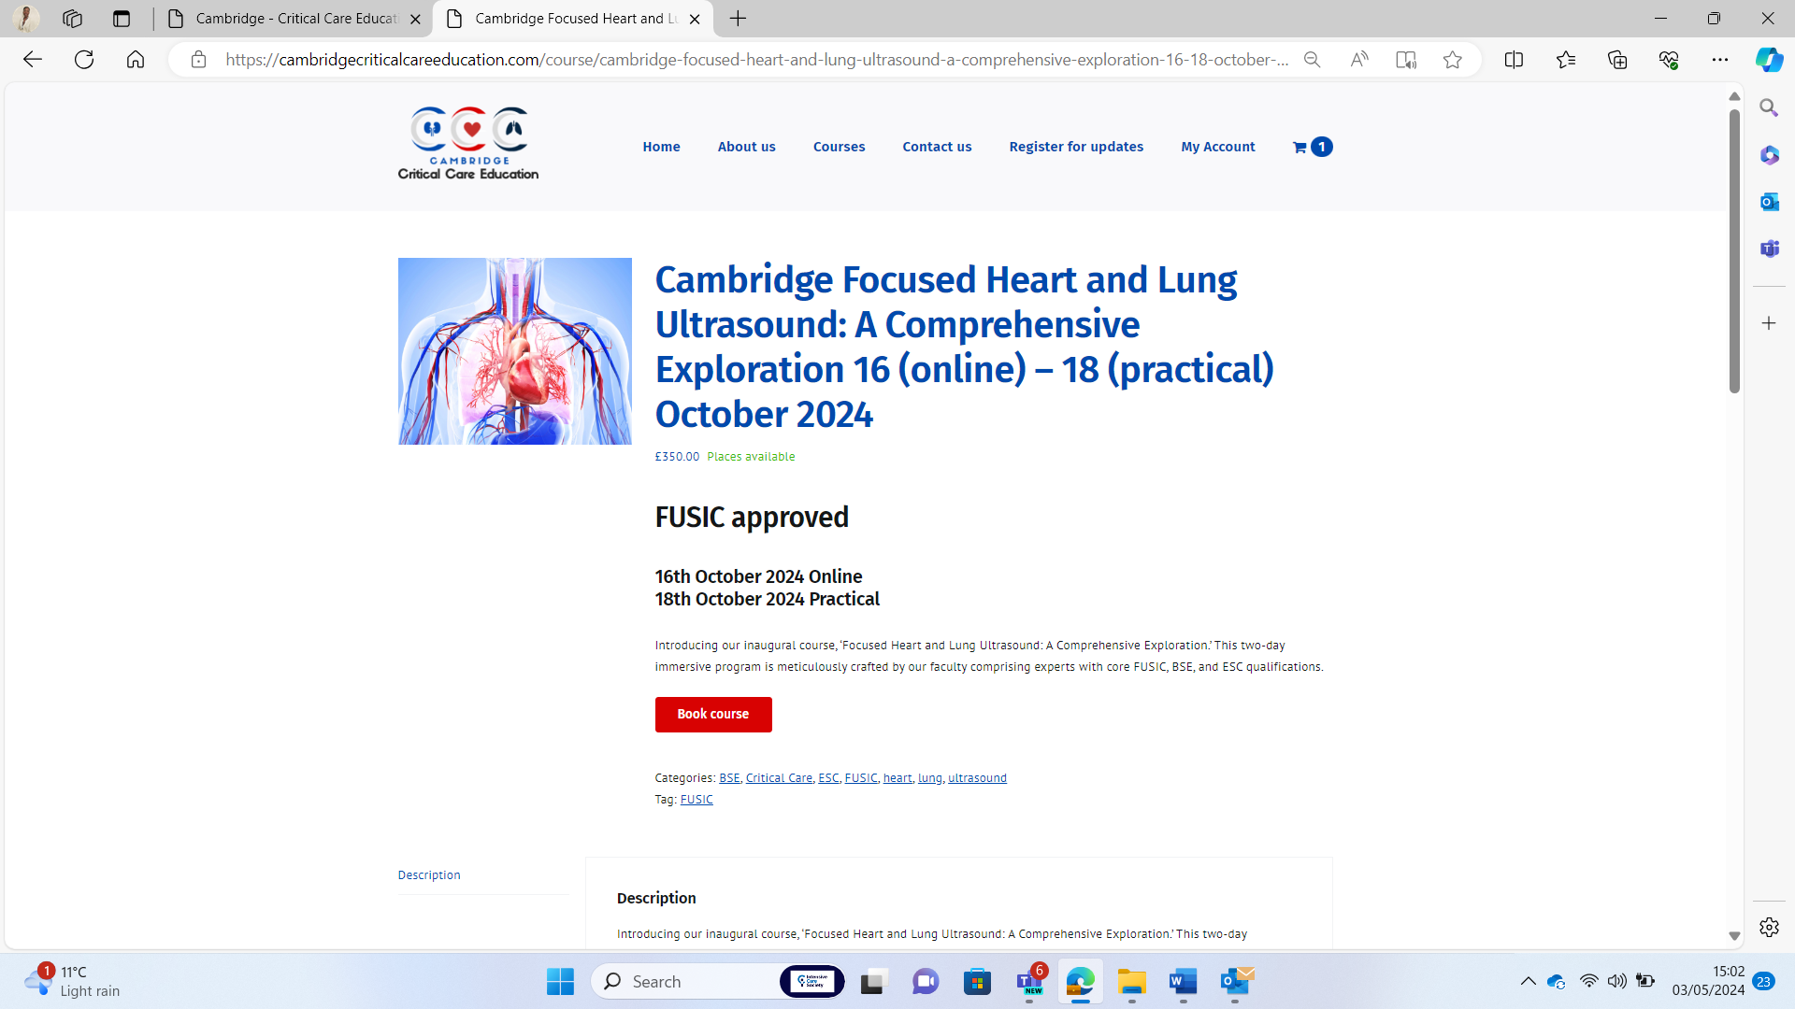

[Cambridge Focused Heart and Lung Ultrasound: A Comprehensive Exploration 16 (online) - 18 (practical) October 2024 - Cambridge Critical Care Education](https://cambridgecriticalcareeducation.com/course/cambridge-focused-heart-and-lung-ultrasound-a-comprehensive-exploration-16-18-october-2024-copy/)

