- Observation

- Date |  |  |  |  |  | Location  (Hospital & Ward/Area) |  | __________________
- Job role of person performing task

​​☐​ Consultant |  | ​​☐​ Band 6+ nurse |  |  |  | ​​☐​ Pharmacist |  | ​​☐​ Other:
​​☐​ Specialty doctor |  | ​​☐​ Band 5 nurse |  |  |  | ​​☐​ Physiotherapist
​​☐​ Doctor in training |  | ​​☐​ Student nurse |  |  |  | ​​☐​ Dietician
​​☐​ Fellow/ Trust grade |  | ​​☐​ CSW |  |  |  | ​​☐​ SLT
​​☐​ Student doctor |  | ​​☐​ Domestic
- Location of task performed

​​☐​ Clean utility |  | ​​☐​ Sluice |  |  |  | ​​☐​ Side room |  | ​​☐​ Other:
 |  |  |  |  |  | ​​☐​ Outside side room
☐​ Under isolation precautions |  |  |  |  |  | ​​☐​ Bed space
- Sequence of items/ objects touched in this episode of care with points of hand hygiene/ glove use
Use to categorise the risk of cross-contamination in one or more of ‘My 5 moments of hand hygiene’ at end of the observation

 |  |  |  | HH | G |  |  |  |  | HH | G
1 |  |  |  | ​​☐​ | ​​☐​ | 7 |  |  |  | ​​☐​ | ​​☐​
2 |  |  |  | ​​☐​ | ​​☐​ | 8 |  |  |  | ​​☐​ | ​​☐​
3 |  |  |  | ​​☐​ | ​​☐​ | 9 |  |  |  | ​​☐​ | ​​☐​
4 |  |  |  | ​​☐​ | ​​☐​ | 10 |  |  |  | ​​☐​ | ​​☐​
5 |  |  |  | ​​☐​ | ​​☐​ | 11 |  |  |  | ​​☐​ | ​​☐​
6 |  |  |  | ​​☐​ | ​​☐​ | 12 |  |  |  | ​​☐​ | ​​☐​
- If gloves put on

 |  | ​​☐​ Clean utility |  |  |  | Location removed |  | ​​☐​ Clean utility
 |  | ​​☐​ Sluice |  |  |  |  |  | ​​☐​ Sluice
 |  | ​​☐​ Side room |  |  |  |  |  | ​​☐​ Side room
 |  | ​​☐​ Outside side room |  |  |  |  |  | ​​☐​ Outside side room
 |  | ​​☐​ Bed space |  |  |  |  |  | ​​☐​ Bed space
 |  | ​​☐​ Other: |  |  |  |  |  | ​​☐​ Other:
Was this as close to the point of use as possible/ practicable? |  | ​​☐​ Y | ​​☐​ N |  |  | Was this as close to the point of use as possible/ practicable? |  | ​​☐​ Y | ​​☐​ N
- Adequate hand hygiene after gloves removed?
With either alcohol based hand rub or soap & water, as close to the point of disposal as possible

 |  |  |  |  |  |  |  | ​​☐​ Y | ​​☐​ N

- Analysis

- Procedure(s) performed during this observation
Use to categorise the risk of cross-contamination in one or more of ‘My 5 moments of hand hygiene’ at end of the observation

 | Procedure |  |  | Gloves used? |  |  |  | Risk of contact with BBF*? |  | Glove use appropriate?
1 |  |  |  | ​​☐​ Y |  | ​​☐​ N |  | ​​☐​ Y | ​​☐​ N | ​​☐​ Y | ​​☐​ N
2 |  |  |  | ​​☐​ Y |  | ​​☐​ N |  | ​​☐​ Y | ​​☐​ N | ​​☐​ Y | ​​☐​ N
3 |  |  |  | ​​☐​ Y |  | ​​☐​ N |  | ​​☐​ Y | ​​☐​ N | ​​☐​ Y | ​​☐​ N
4 |  |  |  | ​​☐​ Y |  | ​​☐​ N |  | ​​☐​ Y | ​​☐​ N | ​​☐​ Y | ​​☐​ N
*Risk of contact with BBF, mucous membranes, hazardous substances or patient under isolation precaution
- Was there a risk of cross contamination*? |  |  |  |  | - If yes, which ‘moments of hand hygiene’?
 |  | ​​☐​ Y | ​​☐​ N |  | 1 |  | ​​☐​ | Before contact with patient zone
*Assess from list of items touched, time of glove use and hand hygiene, and procedures undertaken. Indicate at which ‘moment/s’ the potential for cross contamination occurred. |  |  |  |  | 2 |  | ​​☐​ | Before contact with susceptible site
 |  |  |  |  | 3 |  | ​​☐​ | After contact with blood/ bodily fluid
 |  |  |  |  | 4 |  | ​​☐​ | After contact with patient zone
 |  |  |  |  | 5 |  | ​​☐​ | After contact with healthcare zone

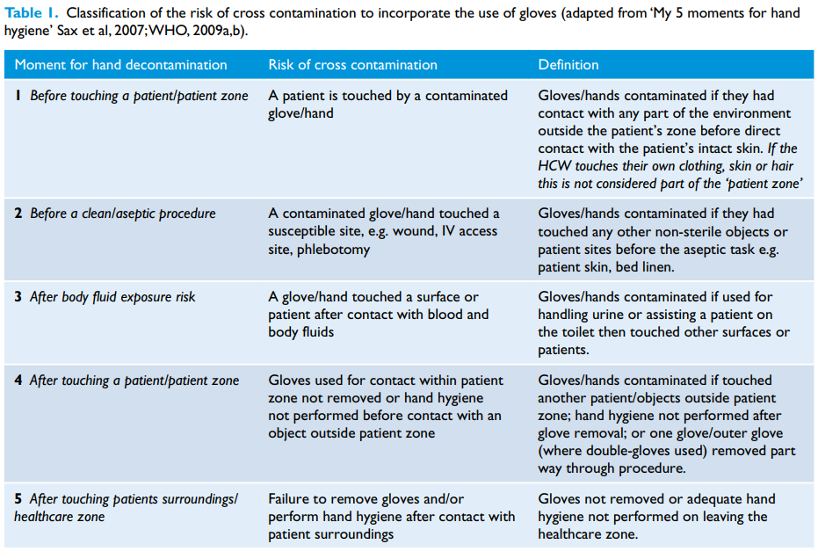
E.g. leaving the bed space before performing hand hygiene
If more than one task is performed with the same pair of gloves
If the staff member did not clean their hands before donning gloves, contamination risk would be here

