+

Live ultrasound scanning in small breakout groups

Sessions covering FAMUS/FUSIC curriculum

**FAMUS & FUSIC courses**

ICS and SAM Accredited Faculty

Friday 4th July 2025 (FAMUS)

Saturday 5th July 2025 (FUSIC)

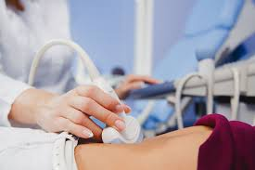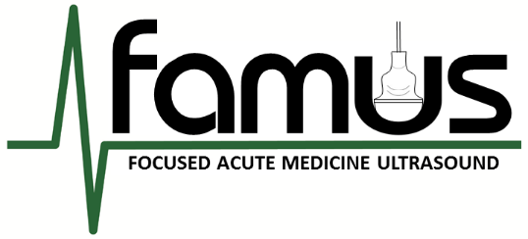

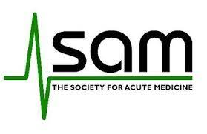

**Exclusive Online Lectures Access**

**Pre/post course Materials**

**Half-Day Practical Scanning Sessions**

• Thoracic • Abdomen

• DVT • Vascular Access

**Venue:**

**Burnley General Teaching Hospital**

**Price:**

**Early-bird Discount: sign up before 31/03/25**

1 Day £300 / Or both £500

**Standard Price: sign up from 01/04/25**

1 Day £350 / Or both £600

**Lunch and refreshments provided**

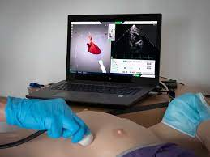

**Exclusive Online Lectures Access**

**Pre/post course Materials**

**Practical Scanning Sessions**

• Principles/Heart Views

• LV and RV: Size and Function

• Pericardial effusion & tamponade

• Haemodynamic assessment

• IVC measurement

• FUSIC Heart accreditation process

**To register for either or both courses, please email: ultrasoundcourse@elht.nhs.uk**